No. of Pages | 3
No. of Questions | 4

Department of Computer Science and Engineering
MIDTERM EXAMINATION Fall 2010

CSE320: Data Communications
Total Marks: 60 Time Allowed: 70 minutes
- Answer ALL Four (4) questions
- Figure in bracket [] next to each question indicates marks for that question

Question No. 1

- Match the following functions to the appropriate layers of the OSI model : [4 marks]
  - How PCs connect to create a topology.
  - Ensuring data retransmission if data is corrupted.
  - How bits are converted into electrical signals.
  - Encryption of passwords and usernames.
  - Logging the user out from an application when user remains inactive for a long time.
  - Requesting sender to send less packets.
  - Changing the path to reach destination if congestion occurs.
  - Changing MAC addresses hop to hop.
- Differentiate between IP address, MAC address and Port numbers. [3.5 marks]
- “TCP/IP Model”, what is this model for? Explain briefly. [3 marks]

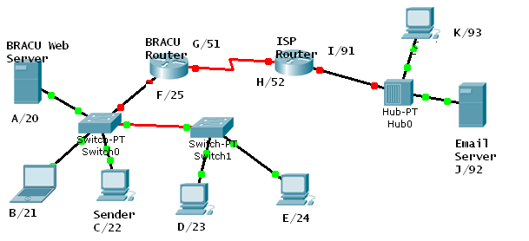
Packet 2
Packet 1
Packet 3
Figure No. 1

- Complete the packets shown above sent by Sender C/22 with appropriate addresses (all three addresses). The sender has two applications running one for email with port number of 49160 and the other for accessing the http server with port number 49152. The packet 1 and packet 2 shown are intended for the Email server. The packet 3 is from Sender C/22 to the BRACU Web Server. (Use the separate sheet provided). Assume the alphabets to be MAC addresses and the numbers to be IP addresses. [4.5 marks]

Question No. 2

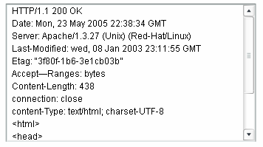
Figure No. 2
- What does the “HTTP/1.1 200 K” shown in figure no. 2 mean to you, explain briefly? What will this output shown in figure no. 2 display to the user? [4 marks]
- Which application layer protocol allows you to access any device situated at Standard Tower while sitting in your office at UB building? But this protocol has a disadvantage what is it? [3 marks]
- When you write www.cisco.com in the URL of a web browser, the first packet sent by your PC is to your local DNS server. Why? And how does your PC know where to find the local DNS server? [4 marks]

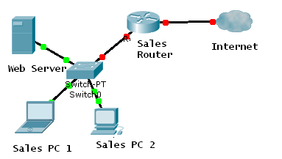
Figure No. 3

- The above network shown in figure no. 3 uses DHCP to configure the IP addresses. Should the net administrator use DHCP for all devices, why or why not? [4 marks]

Question No. 3

- A packet is sent by a host connected to the Internet with a destination IP address which does not exist. What will happen to that packet? [3 marks]

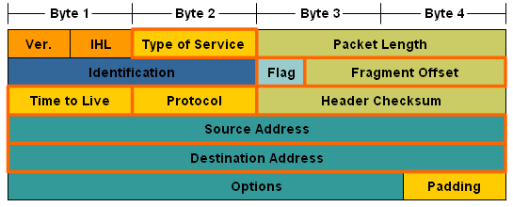
Figure No. 4

- The above figure no. 4 is the IP header. Explain the purpose of the 2nd line of the header (the fields within the oval shape). [4 marks]
- Refer to the network shown in figure no. 3, Sales PC 2 has no connectivity to the Internet but can connect Sales PC 1 and the web server. What can be the problem and also state the solution? [4 marks]
- Why are we recommended to divide a large network into small sub-networks? On what basis can we divide the large network into small sub networks? [4 marks]

Question No. 4

- Differentiate between Well Known Port Numbers and Dynamic Port Numbers. [3 marks]
- Host A is terminating a TCP connection with Host B, draw the process. Which code bit does Host A use, and why? [4 marks]
- During a TCP communication session, if the packets arrive to the destination out of order, what will the receiving host do? What happens if it is an UDP communication? [4 marks]
- Two hosts are sending data to each other. During connection establishment, the negotiated window size was 500 bytes. After a while the receiving host could not process segments from 501 no. bytes to 1000 no. bytes due to it’s buffer overflow, what kind of information in the segment does the receiving host send to control the flow and acknowledge? [ 4 marks]

THE END

